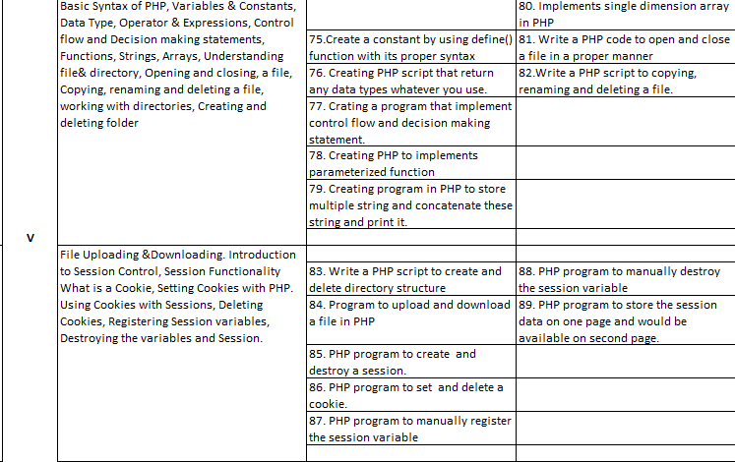

NOTES unit 5
Basic Syntax of PHP, Variables & Constants, Data Type, Operator & Expressions, Control flow and Decision making statements, Functions, Strings, Arrays,
Understanding file& directory, Opening and closing, a file, Copying, renaming and deleting a file, working with directories, Creating and deleting folder, File Uploading &Downloading.
https://www.w3schools.com/php/php_file_open.asp

Introduction to Session Control, Session Functionality What is a Cookie, Setting Cookies with PHP. Using Cookies with Sessions, Deleting Cookies, Registering Session variables, Destroying the variables and Session.
https://www.w3schools.com/php/php_sessions.asp
A comprehensive explanation of PHP's session control and cookie management, incorporating examples and step-by-step explanations:
Introduction to Session Control
Sessions in PHP provide a mechanism to store data associated with a specific user across multiple web pages. This data is stored on the server-side, ensuring security and persistence. Sessions are typically used for:
- User authentication: Storing login information to maintain user identity throughout a session.
- Shopping carts: Tracking items added to a user's cart.
- User preferences: Remembering user settings, such as language or theme choices.
Session Functionality
- Session ID: A unique identifier assigned to each session, used to track data associated with that specific user.
- Session variables: Variables created within a session scope, accessible throughout the session's lifetime.
- Session storage: Data is typically stored on the server, but can also be stored in databases or other persistent storage mechanisms.
What is a Cookie
Cookies are small text files stored on the client's (user's) computer by a web server. They are used to store information about the user's preferences, session state, and other data. Cookies can be:
- Session cookies: Temporary cookies deleted when the browser closes.
- Persistent cookies: Cookies stored on the user's computer for a specified duration.
Setting Cookies with PHP
To set a cookie in PHP, use the setcookie() function:
PHP
setcookie("username", "John Doe", time() + 3600);
This code sets a cookie named "username" with the value "John Doe" that expires in one hour.
Using Cookies with Sessions
Cookies can be used to store the session ID, allowing the server to identify the user's session across different pages. This is typically done automatically by PHP's session handling mechanism.
Deleting Cookies
To delete a cookie, set its expiration time to a past date:
PHP
setcookie("username", "", time() - 3600);
This code deletes the "username" cookie.
Registering Session Variables
To register a session variable, use the $_SESSION array:
PHP
$_SESSION["user_id"] = 123;
$_SESSION["cart"] = array("item1", "item2");
This code registers two session variables: "user_id" with the value 123 and "cart" with an array of items.
Destroying the Variables and Session
To destroy a specific session variable, unset it from the $_SESSION array:
PHP
unset($_SESSION["cart"]);
To destroy the entire session, use the session_destroy() function:
PHP
session_destroy();
Example Program
PHP
<?php
session_start();

// Check if the user is logged in
if (!isset($_SESSION["logged_in"])) {
header("Location: login.php");
exit();
}

// Display the user's name
echo "Welcome, " . $_SESSION["username"];

// Display the cart contents
if (isset($_SESSION["cart"])) {
echo "Your cart contains: ";
foreach ($_SESSION["cart"] as $item) {
echo $item . ", ";
}
}

// Destroy the session after 30 minutes
if (time() - $_SESSION["last_activity"] > 1800) {
session_destroy();
header("Location: login.php");
exit();
} else {
$_SESSION["last_activity"] = time();
}
?>
This example program demonstrates how to use sessions to store user login information, cart contents, and last activity time. It also implements a session timeout mechanism to automatically log out the user after 30 minutes of inactivity.

